**Diamond Model Portfolio at a Glance**

Features:

* Trend following rotational approach
* Trades ASX All Ordinaries stocks
* Trades weekly
* High expectancy
* Long holding period
* Low turnover
* Smooth consistent returns
* Inbuilt protection from adverse market conditions

**Key Metrics**

|  |  |
| --- | --- |
| Compound Annual Return | 21% |
| Max Historical Drawdown | 18% |
| Average Holding Period | 12 Weeks |
| Average Trades Per Year | 34 |
| Average Winning Trade | 22% |
| Average Losing Trade | 8% |
| Win Rate | 57% |
| Max Consecutive Wins | 12 |
| Max Consecutive Losses | 12 |

*See below for full metrics and charts as well as a detailed account of the system’s approach and risk management principles.*

**Diamond Model Portfolio Detailed Results 2005 to date**

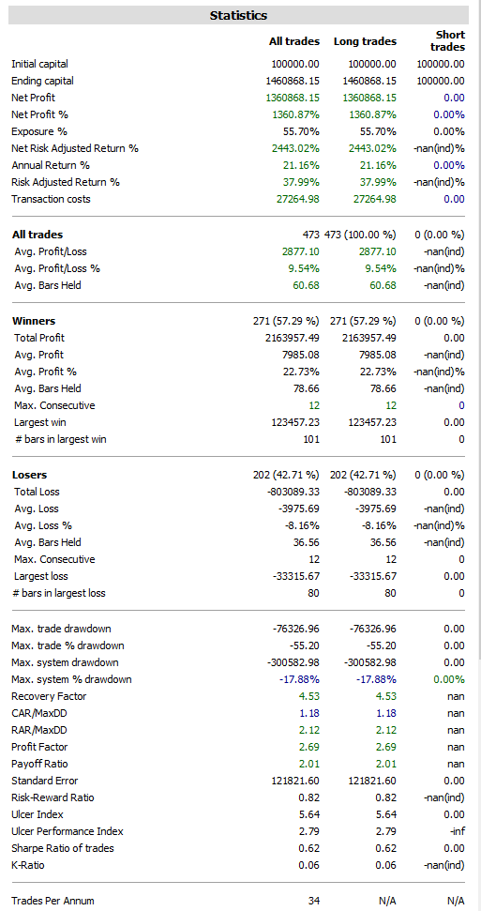

**Portfolio Equity (Green/Orange) versus All Ordinaries Index (Black Line)**

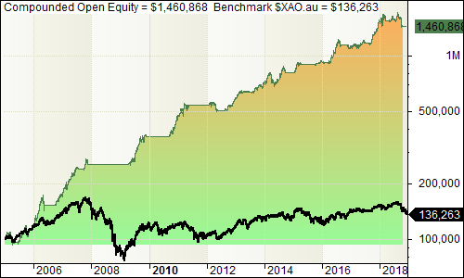

**Open Equity Drawdown**

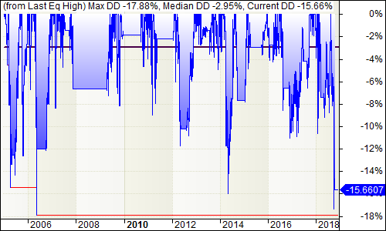

**Annual Compounded Return**

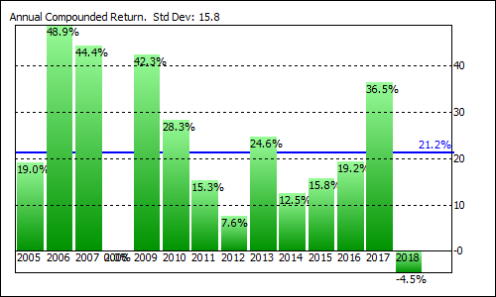

**Month by Month Profit**

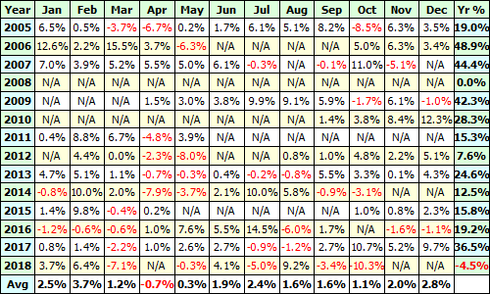

N/A on past months denotes no market exposure, ie the strategy was in cash

**Closed Equity**

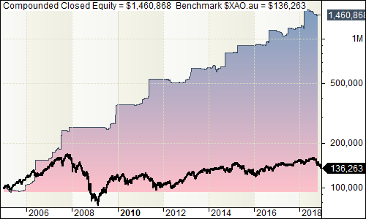

**Closed Equity Drawdown**

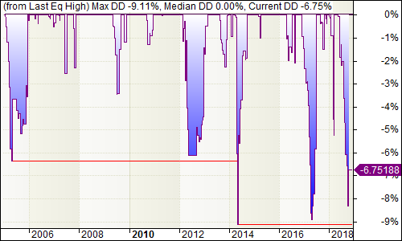

**Trade P&L v Duration**

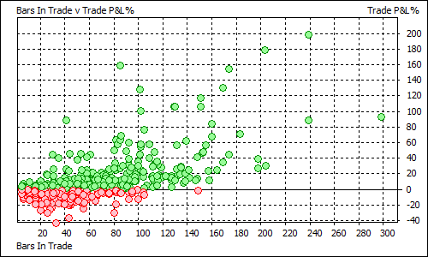

## Diamond Key Features

Diamond aims to produce smooth consistent gains profiting from market momentum, with a medium term holding period, low turnover and aggressive risk management.

|  |  |
| --- | --- |
| Approach | Rotational Trend Following |
| Direction | Long only |
| Stock Universe | Constituents of the ASX All Ordinaries Index |
| Liquidity Filter | System has minimum price and turnover liquidity filters built in to avoid trading illiquid issues |
| Volatility Filter | A volatility filter eliminates stocks with very low volatility such as takeover stocks and those with few trades. |
| Ranking Score | A momentum based ranking methodology is used to determine the strongest stocks in the index. This measures the strength of all stocks on a scale of 0 to 100 – higher is stronger. Any stocks failing to pass the other system filters are ranked at zero. |
| Market Regime Filter | A market based regime filter ensures the system only trades when market conditions are favourable and seeks to reduce risk when otherwise. During adverse market conditions, only the strongest stocks with a very high ranking score continue to be held. |
| Max Positions | The system aims to hold up to 14 of the strongest stocks in the index, subject to the above filters |
| Rotation | Stocks are re-ranked weekly on a Friday. Any holdings falling out of the top 21 or otherwise eliminated by the filters are sold and the remainder are held. Any new entrants to the top 14 list are bought, subject to a free slot being available. |
| Position Size | The system is based on a fixed fractional position size of 7.14% of account capital per position. If fewer than 14 stocks are available to be held, the balance is held in cash. |

|  |  |
| --- | --- |
| Exit Strategy | The system has two complementary exit triggers. The primary exit is momentum based and will sell down a stock that has lost momentum relative to other holdings when it’s no longer strong enough to remain in the holdings list of ranked stocks. The momentum based exit will tend to exit in the middle of the price range during the “distribution” phase following an uptrend and will tend to avoid capitulation points, such as where price-based stops would normally be triggered. This action of selling a stock losing momentum whilst buying a stock gaining momentum also produces a smoothing effect in the results. Additionally the market regime filter will sell down holdings and reduce risk when market-wide conditions turn adverse. |
| Executions | Buy and Sell signals are available on a Friday evening after the market is closed and once the data is available for processing. Trade executions can be made at the following Monday’s market open. |

Each week on a Friday, the full list of index rankings, trade history and system results are published on the Helix Trade website and are available to be viewed by subscribers.

A listing of the holdings along with any buys and sells are provided by email to subscribers. An example of the weekly ranking table with signals can be seen below.

In this example, holdings in BAP and CIM would have been sold and new positions opened in GXY and SLR. The balance of positions would have continued to be held.

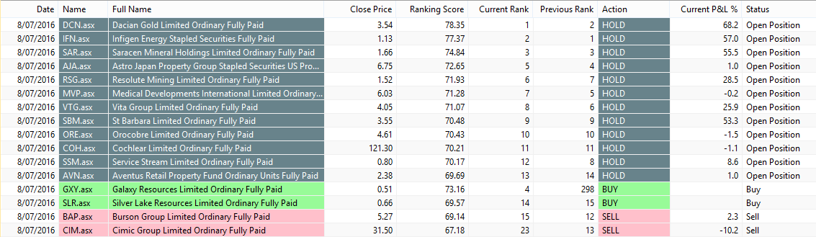

## System Risk Controls

The Diamond system has a number of risk controls to both enhance returns and provide adequate risk management.

**Stock Rotation**

If the system has a full book of 14 positions, then each week stocks are re-ranked and any that have dropped out of the top 21 are sold, any new members of the top 14 that week are bought, subject to a free slot being available. This has the effect of selling stocks whose trends are losing strength and buying stocks whose trends are gaining strength. This crossover has the tendency to smooth out the gains over time. Allowing held stocks to move to a floor of position 21 before being sold gives stocks “breathing space” while trends are pausing or developing. This reduces system turnover and improves overall performance.

**Market Regime Filter**

The system uses an index-based filter to gauge the overall health of the market. When that quantifiably turns adverse, the system will sell down all but the strongest positions. This provides protection from sharp market corrections and bear markets. The algorithm actually has an anticipative element to it, so it will often get out just prior to market tops, again giving an improved smoothness to returns.

**Momentum Exit**

When the system's Market Filter is negative, the system only holds the strongest performing stocks, based on a measure of their trend's momentum. This is the Ranking Score you see in the results table each week. When the momentum falls below a minimum required level (and the market filter is still negative), it will be sold. Having a momentum, rather than price based stop means the trade will tend to exit when the market turns sideways and before it drops, if it does go on to do that. Hence, the system more often than not sells in the middle of the price range, rather than at a capitulation point, as a price-based stop more likely would. This tends to result in better system returns and less drawdown. Of course if the upward trend is re-established and the ranking score gets above the minimum again, then the position will be re-established. The momentum exit restriction is removed when the market filter turns positive once again, and the system then relies solely on the rotational exit. This allows the system to capitalise on more favourable market conditions.

**Position Sizing**

Position sizing plays a key role in managing risk, specifically individual instrument risk. With up to 14 positions allowed, then using a Fixed Fractional position sizing approach, each trade makes up only just over 7% of capital invested. Therefore if there is a sharp adverse move in a position, then that has only a small impact on the account compared with having a fewer number of positions held, with what would be a higher percentage of equity in each.

**Sector Maximum Holding**

A maximum of 3 stocks can be held from any single sector. This reduces sector specific risk, by avoiding a high concentration of the portfolio in any one area.

**Disclaimer**

Helix Trader nor any of its affiliates, directors or agents are a financial advisory service, nor a licensed financial advisor and do not provide financial advice whatsoever in any financial products. You understand and acknowledge that there is a very high degree of risk involved in trading securities and derivatives. In particular, trading leveraged instruments such as Futures, Contracts for Difference or Options can amplify the losses as well as gains achieved due to market price fluctuations, and you may lose more than your original investment.

All methods, techniques, charts or analysis presented in Helix Trader are for educational purposes only. The information provided should not be construed in any way as a recommendation to buy or sell any financial instrument. You should always consult with your licensed financial advisor and tax advisor to determine the suitability of any investment to your particular financial situation. Helix Trader and its affiliates, directors or agents will not be held liable or responsible for your investment decisions.

Further it should not be assumed that any methods, techniques or indicators presented in the training will be profitable or that they will not result in losses. Past results of any individual trader or trading system presented are not indicative of future returns by that trader or system, and are not indicative of future returns which may or may not be realised by you.

Hypothetical or simulated performance results have certain inherent limitations. Unlike

an actual performance record, simulated results do not represent actual trading and may

not be impacted by brokerage, slippage and other fees. Also, since the trades have not

actually been executed, the results may have under or over-compensated for the impact,

if any, of certain market factors, such as lack of liquidity. Simulated trading systems in

general are also subject to the fact that they are designed with the benefit of hindsight.

No representation is being made that any account will or is likely to achieve profits or

losses similar to those demonstrated.